Lab02 answer

# Diagram.

## 1.1. Use case Diagram.

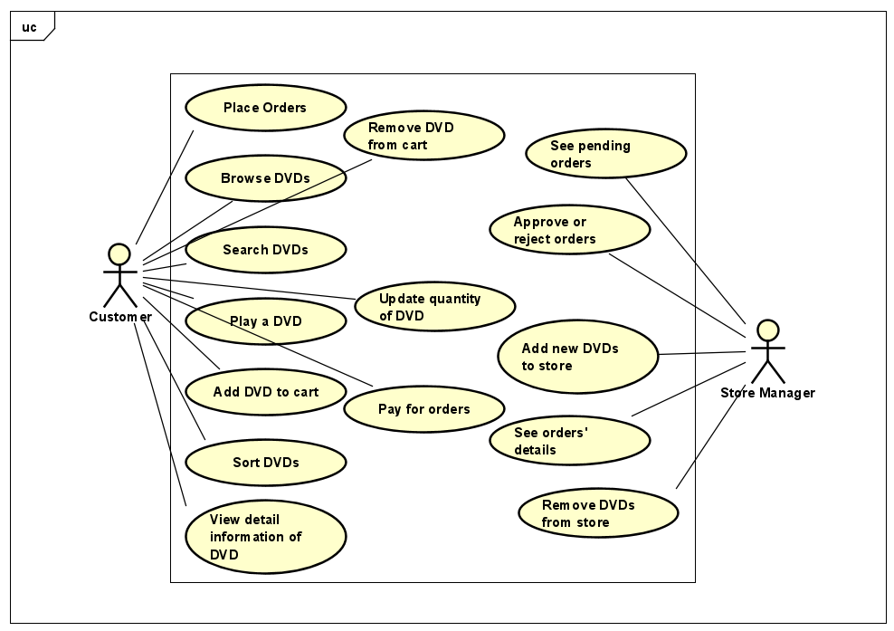

## 1.2. Class Diagram.

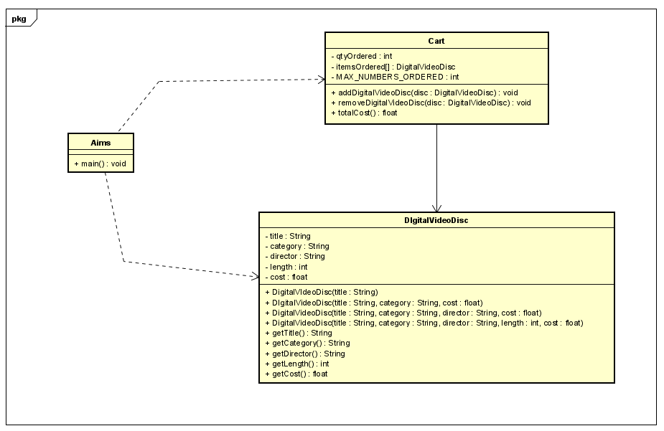

# Source code.

## 2.1. DigitalVideoDisc class.

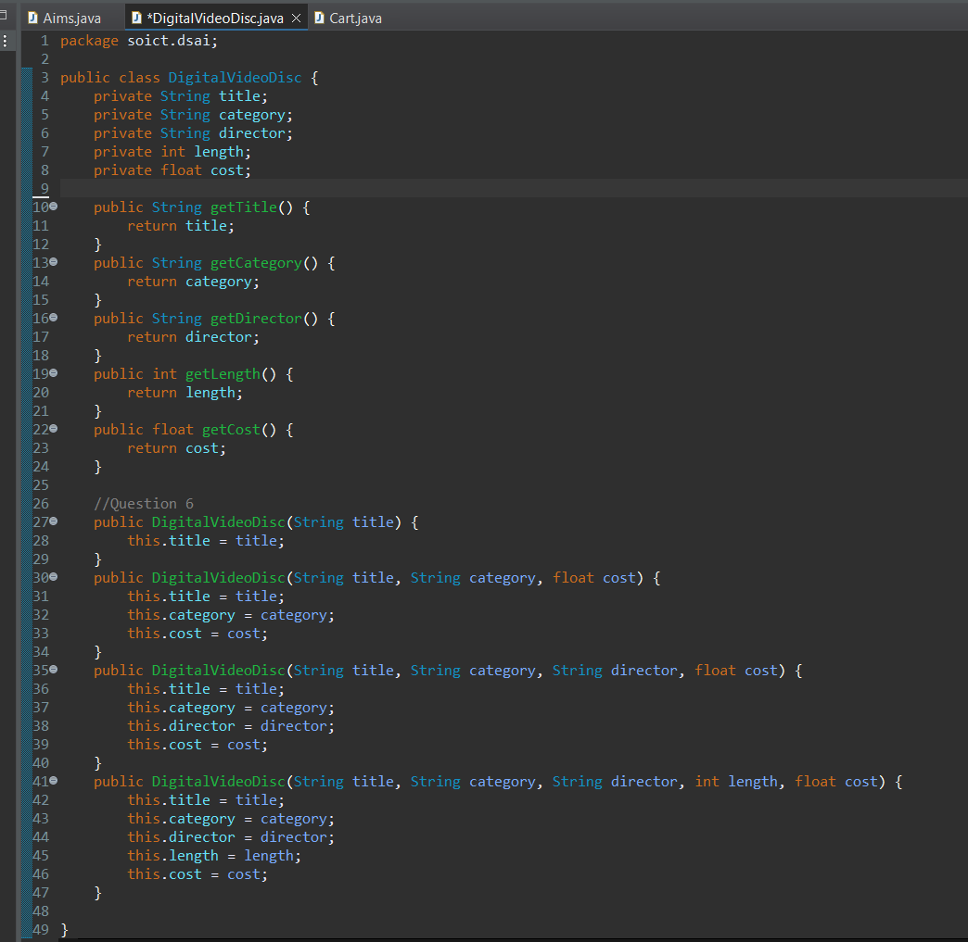

## 2.2. Aims class.

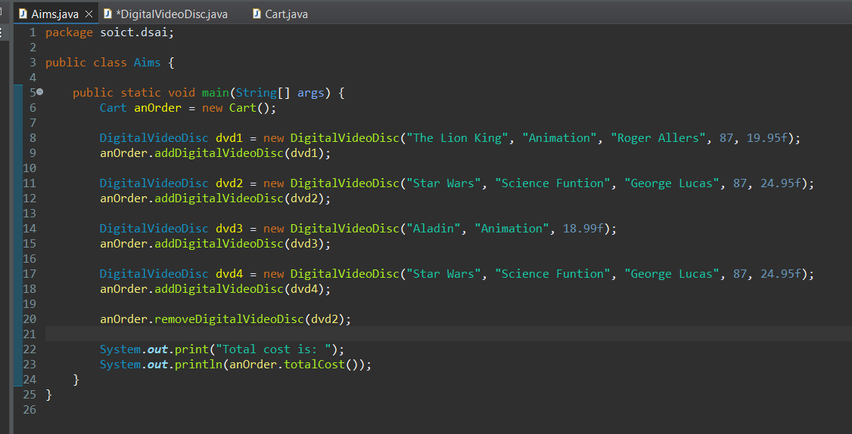

## 2.3. Cart class.

### 2.3.1. addDigitalVideoDisc method.

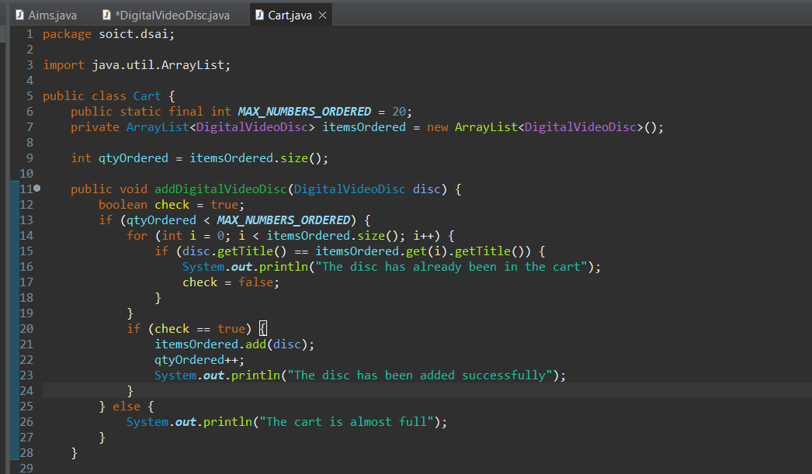

### 2.3.2. removeDigitalVideoDisc method.

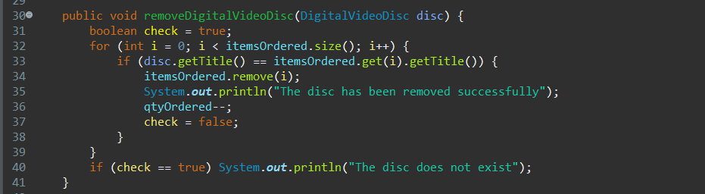

### 2.3.3. totalCost method.



# Reading Assignment.

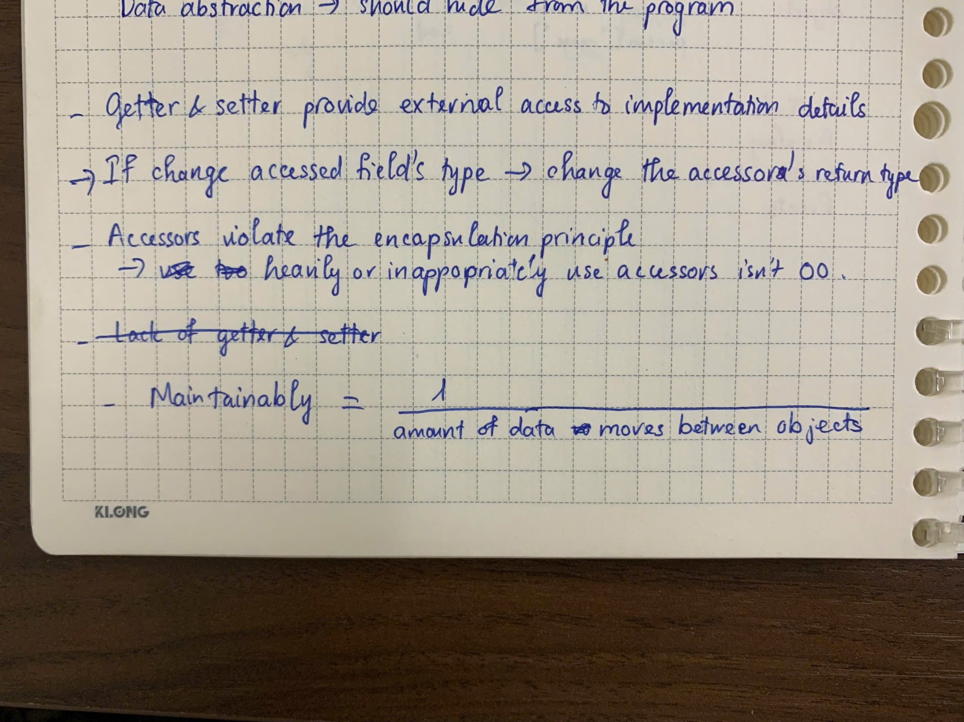

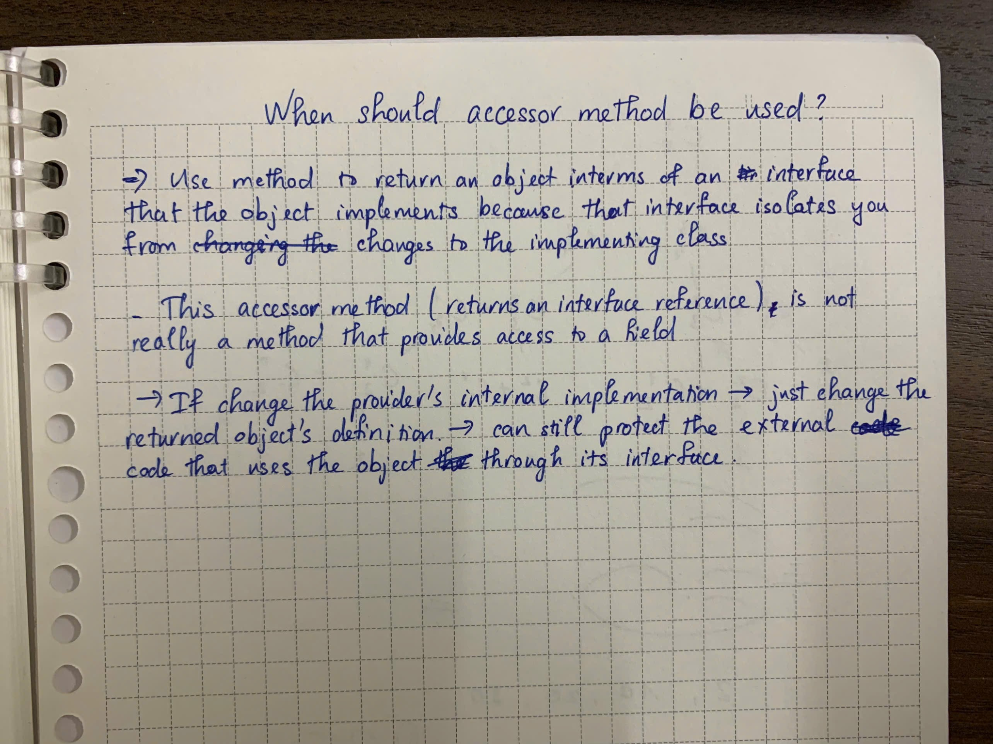

# Answer questions.

## 4.1. If you create a constructor method to build a **DVD** by title then create a constructor method to build a **DVD** by category. Does JAVA allow you to do this?

* Java not allow to do this because these 2 constructors have the same input type “String”. This lead to duplicate methods DigitalVideoDisc(String), Java cannot recognize it is a title or a category, just String and String.